# Creating a Solana Wallet

VIDEO

Solana has grabbed the spotlight recently. The project is now on the list of top 8 cryptocurrencies worldwide, according to [Forbes](https://www.forbes.com/sites/jonathanponciano/2021/08/31/solana-skyrockets-to-new-high-above-130-amassing-nearly-40-billion-in-market-value-as-competition-with-ethereum-heats-up/?sh=79314e9e4353).

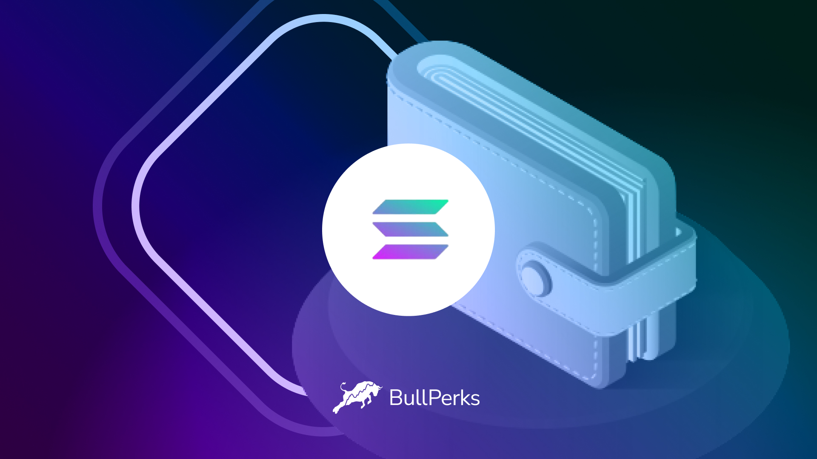

To join fantastic projects on Solana, you have to set up a wallet on the Solana blockchain first.

Since you cannot add the Solana network to your MetaMask, we created this quick guide about how to set up a Solana wallet.

First, you will need to go to the Solana [official website](https://www.sollet.io/).

Once you enter a website, press OK. Choose any of the available wallet apps for your browser after you set up your Solana wallet.

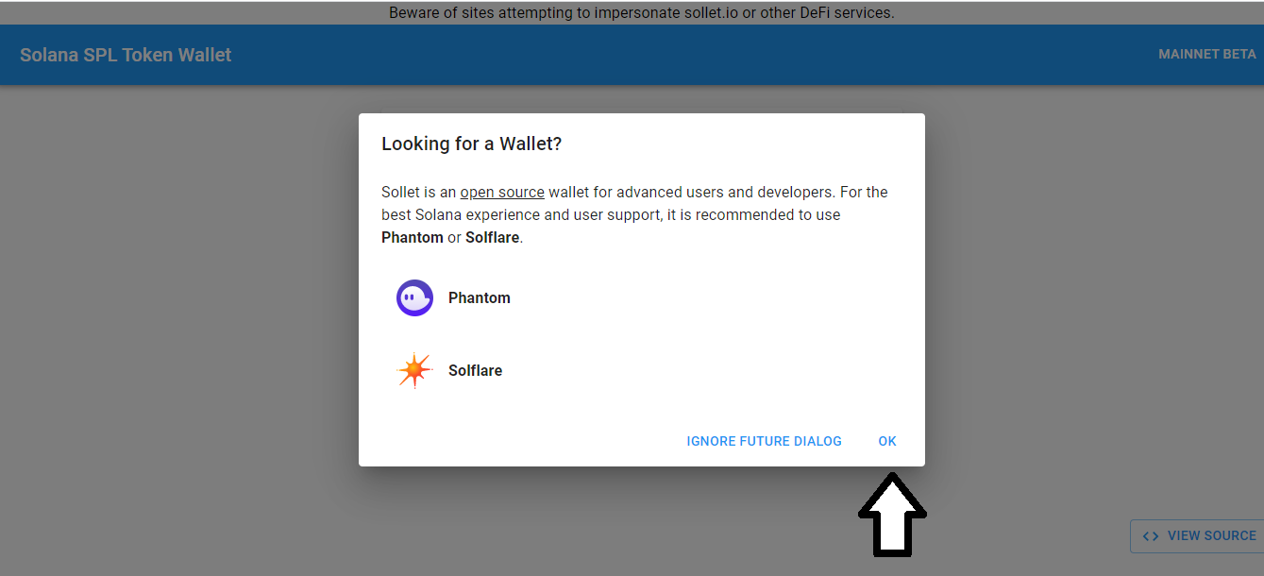

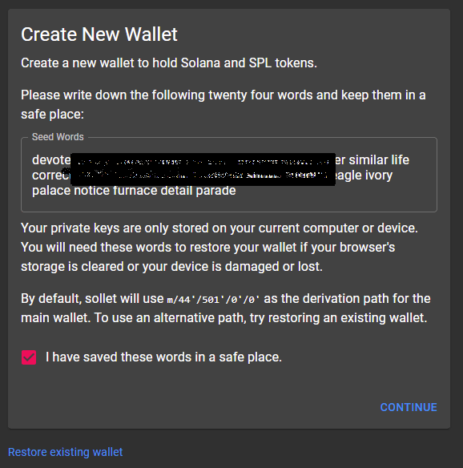

Make sure you have written down and saved your private keys in a secure place. Tick the box if you saved the phrase and press “Continue”.

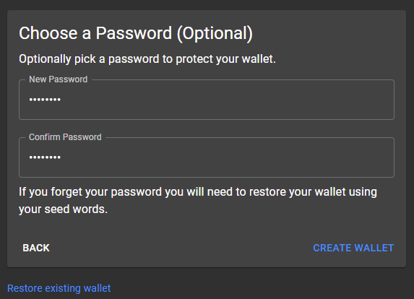

Press “Continue” and create a password for your wallet. Keep in mind that your password should be unique and longer than 8 characters. It must also contain a number and uppercase for more security.

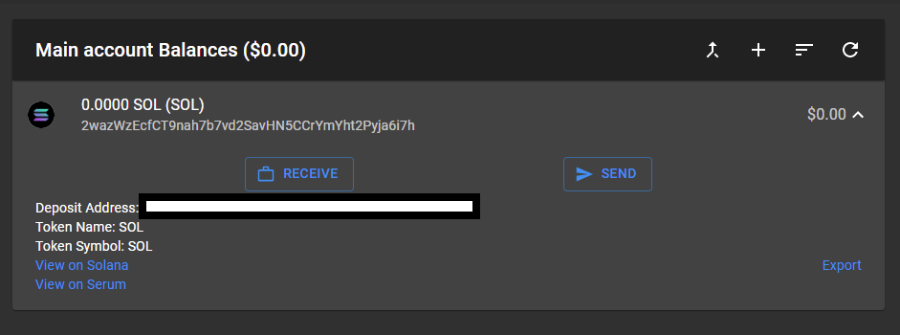

Once you confirm your password, your Solana token wallet is set up. Now, you will be able to buy, send, and receive Solana-based tokens.